Course Name: | Foundations of Generative AI Laboratory | Semester: | IV
Date of Performance: | 7 / 4 /2026 | Batch No: | A4(CSBS)
Faculty Name: | Prof. Dinesh Auti | Roll No: | 1605024081
Faculty Sign & Date: |  | Grade/Marks: | ___/15

Experiment No: 8
Title: Image-to-Image Translation using GANs (CycleGAN)

Aim and Objective of the Experiment:
To implement an Image-to-Image Translation model using CycleGAN that learns mappings between two different image domains without requiring paired training data, enabling the transformation of images from one domain to another while preserving their structural content.

COs to be achieved:
CO2: Develop skills to implement and train generative models using deep learning frameworks.
CO3: Explore and apply various generative models such as GANs, VAEs, and flow-based models.

Tools used:
- Python 3.x
- TensorFlow / Keras
- PyTorch
- Jupyter Notebook / Google Colab
- NumPy
- Matplotlib (optional)

Theory:
CycleGAN uses two generators and two discriminators to translate images between two domains. The generators convert images from one domain to another, while discriminators check if the generated images are real or fake. The key concept is cycle consistency loss, which ensures that an image translated to another domain and back remains similar to the original. This helps maintain content while changing appearance.

Code:
Write a simple program to implement an Image-to-Image Translation model using CycleGAN that learns mappings between two different image domains, enabling the transformation of images from one domain to another while preserving their structural content.
CODE :
# =========================
# FINAL WORKING CYCLEGAN (MNIST) - ONE CELL
# =========================

import tensorflow as tf
from tensorflow.keras import layers
import numpy as np
import matplotlib.pyplot as plt

# -------------------------
# 1. Load MNIST dataset
# -------------------------
(x_train, _), (_, _) = tf.keras.datasets.mnist.load_data()

# Normalize to [-1,1]
x_train = (x_train / 127.5) - 1
x_train = np.expand_dims(x_train, axis=-1)

# -------------------------
# 2. Create domains
# -------------------------
A = x_train
B = -x_train

# Resize to 64x64
A = tf.image.resize(A, [64,64])
B = tf.image.resize(B, [64,64])

dataset = tf.data.Dataset.from_tensor_slices((A, B)).shuffle(1000).batch(1)

# -------------------------
# 3. Generator
# -------------------------
def build_generator():
inputs = layers.Input(shape=(64,64,1))
x = layers.Conv2D(32, 3, padding='same', activation='relu')(inputs)
x = layers.Conv2D(32, 3, padding='same', activation='relu')(x)
outputs = layers.Conv2D(1, 3, padding='same', activation='tanh')(x)
return tf.keras.Model(inputs, outputs)

# -------------------------
# 4. Discriminator
# -------------------------
def build_discriminator():
inputs = layers.Input(shape=(64,64,1))
x = layers.Conv2D(32, 3, strides=2, padding='same')(inputs)
x = layers.LeakyReLU()(x)
x = layers.Conv2D(64, 3, strides=2, padding='same')(x)
x = layers.LeakyReLU()(x)
x = layers.Flatten()(x)
outputs = layers.Dense(1)(x)
return tf.keras.Model(inputs, outputs)

# -------------------------
# 5. Models
# -------------------------
G = build_generator()
F = build_generator()
DX = build_discriminator()
DY = build_discriminator()

# -------------------------
# 6. Loss functions
# -------------------------
loss_fn = tf.keras.losses.MeanSquaredError()

def gen_loss(fake):
return loss_fn(tf.ones_like(fake), fake)

def disc_loss(real, fake):
return loss_fn(tf.ones_like(real), real) + loss_fn(tf.zeros_like(fake), fake)

def cycle_loss(real, cycled):
return tf.reduce_mean(tf.abs(real - cycled))

# -------------------------
# 7. Separate Optimizers (FIXED)
# -------------------------
G_opt = tf.keras.optimizers.Adam(0.0002)
F_opt = tf.keras.optimizers.Adam(0.0002)

DX_opt = tf.keras.optimizers.Adam(0.0002)
DY_opt = tf.keras.optimizers.Adam(0.0002)

# -------------------------
# 8. Training step (FIXED)
# -------------------------
@tf.function
def train_step(real_x, real_y):
with tf.GradientTape(persistent=True) as tape:

fake_y = G(real_x, training=True)
cycled_x = F(fake_y, training=True)

fake_x = F(real_y, training=True)
cycled_y = G(fake_x, training=True)

dx_real = DX(real_x, training=True)
dx_fake = DX(fake_x, training=True)

dy_real = DY(real_y, training=True)
dy_fake = DY(fake_y, training=True)

g_loss = gen_loss(dy_fake)
f_loss = gen_loss(dx_fake)

cycle = cycle_loss(real_x, cycled_x) + cycle_loss(real_y, cycled_y)

dx_loss = disc_loss(dx_real, dx_fake)
dy_loss = disc_loss(dy_real, dy_fake)

total_G_loss = g_loss + 10 * cycle
total_F_loss = f_loss + 10 * cycle

# Gradients
G_grad = tape.gradient(total_G_loss, G.trainable_variables)
F_grad = tape.gradient(total_F_loss, F.trainable_variables)

DX_grad = tape.gradient(dx_loss, DX.trainable_variables)
DY_grad = tape.gradient(dy_loss, DY.trainable_variables)

# Apply gradients (FIXED)
G_opt.apply_gradients(zip(G_grad, G.trainable_variables))
F_opt.apply_gradients(zip(F_grad, F.trainable_variables))

DX_opt.apply_gradients(zip(DX_grad, DX.trainable_variables))
DY_opt.apply_gradients(zip(DY_grad, DY.trainable_variables))

# -------------------------
# 9. Training loop
# -------------------------
EPOCHS = 10

for epoch in range(EPOCHS):
for real_x, real_y in dataset.take(500): # keep small for speed
train_step(real_x, real_y)

print(f"Epoch {epoch+1} completed")

# -------------------------
# 10. Test output
# -------------------------
sample = A[:1]
generated = G(sample, training=False)

plt.subplot(1,2,1)
plt.title("Original")
plt.imshow(sample[0,:,:,0], cmap='gray')

plt.subplot(1,2,2)
plt.title("Translated")
plt.imshow(generated[0,:,:,0], cmap='gray')

plt.show()

Output:
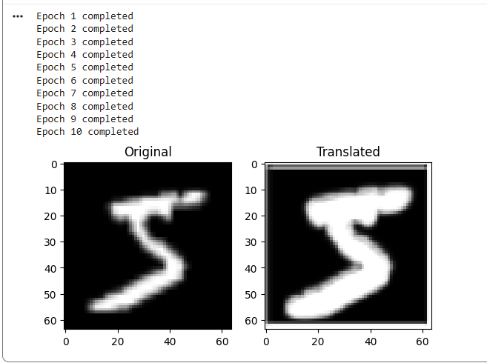

Post Lab Subjective/Objective type Questions:
- What is Image-to-Image Translation and where is it used?
- What problem does CycleGAN solve compared to traditional GANs?
- Explain the concept of cycle consistency loss.
- What are the main components of CycleGAN architecture?
- What role do the two generators play in CycleGAN?
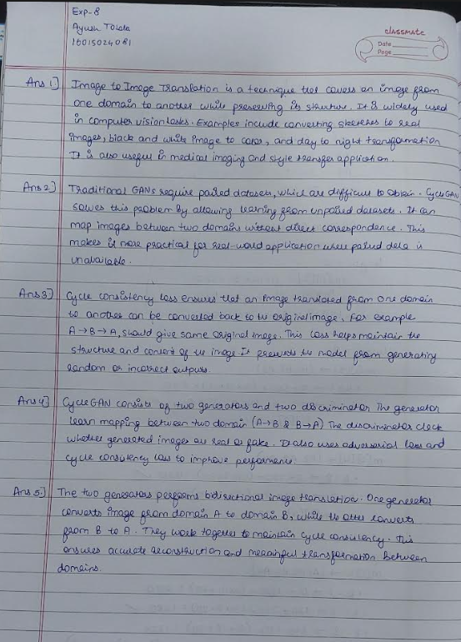

Conclusion:
CycleGAN is an effective model for image-to-image translation that works without paired data by learning mappings between two domains. It preserves the main structure of images while changing their style using cycle consistency loss. This makes it useful in applications like style transfer, object transformation, and domain adaptation.

Signature of faculty in-charge with Date:

